**Juice Bottles at Playgroup**

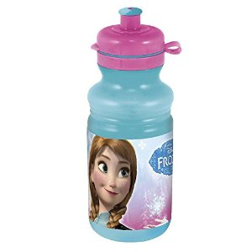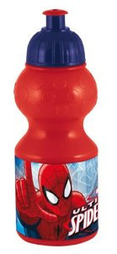 

We at FIG Playgroup like to encourage healthy eating & drinking. Therefore, we kindly ask that **NO** juice be sent in with children for snacktime or if they are only attending a morning or afternoon session at Playgroup. We wish to prevent children from sipping on juice during the Playgroup session as this can affect their health and their teeth.

If your child stays to lunch then juice is allowed but must be in their lunch bag/box and must not be placed on the snack table where other children can drink from or ‘mouth’ your child’s bottle which is unhygienic. We recommend cartons of juice which fit easily into lunch bags/boxes, however if this isn’t possible please place your juice bottle in the juice box provided for lunchtimes.

We always provide unlimited water and milk during the Playgroup session and encourage children to drink this from a cup (or ‘Tippee’ cup). This helps with their development and speech progress.

Thank you for your cooperation.

FIG Playgroup

**Juice Bottles at Playgroup**

 

We at FIG Playgroup like to encourage healthy eating & drinking. Therefore, we kindly ask that **NO** juice be sent in with children for snacktime or if they are only attending a morning or afternoon session at Playgroup. We wish to prevent children from sipping on juice during the Playgroup session as this can affect their health and their teeth.

If your child stays to lunch then juice is allowed but must be in their lunch bag/box and must not be placed on the snack table where other children can drink from or ‘mouth’ your child’s bottle which is unhygienic. We recommend cartons of juice which fit easily into lunch bags/boxes, however if this is isn’t possible please place your juice bottle in the juice box provided for lunchtimes.

We always provide unlimited water and milk during the Playgroup session and encourage children to drink this from a cup (or ‘Tippee’ cup). This helps with their development and speech progress.

Thank you for your cooperation.

FIG Playgroup