**Complaints Form**

**Your Name: ...................................................................**

**Your Address: .........................................................................................................................**

**Your Telephone Number: .............................................**

**If you are complaining on behalf of someone else - do you have their permission? YES NO** (please delete as appropriate)

**Name of Child/Service User ..........................................**

**Address: .................................................................................................................................**

|  |
| --- |
| **Complaint** |
| **Your suggestion/s to resolve complaint** |
| **Signed: Date:** |

**Please continue on a separate piece of paper if required. Thank You**

***HOW TO COMPLAIN***

We regard complaints as valuable in order to improve our service to you.

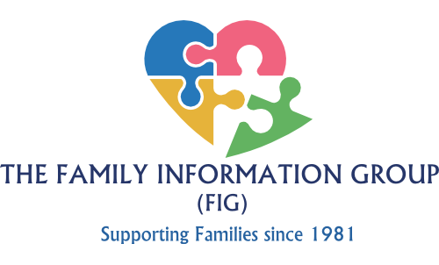

*Taunton Hall, 90 Taunton Road, Harold Hill,*

*Romford, Essex RM3 7SU*

*Telephone: 01708 378141*

*Email:* [*office@familyinformationgroup.co.uk*](mailto:office@familyinformationgroup.co.uk)

*Charity Number: 282399*

**Why Complain?**

You have a right to expect a high quality service from us. Your child has the right to the best care from people who put his/her needs first. At some time, you may have a concern regarding your child’s care. This procedure is designed to bring a fair and prompt response from us and where possible, to resolve the problem to your satisfaction.

**Can I complain about an individual member of staff?**

Yes. If you are unhappy about the actions of any member of staff, then you have the right to make a complaint either to the person concerned, their Supervisor, the Centre Manager or by writing to the Chair of the Family Information Group.

**Can someone represent me?**

Yes. If you would like someone to represent you or act on your behalf, you can ask anyone who isn’t an employee of the Family Information Group to act as your advocate. Employees of the Family Information Group cannot act for you because conflict of interests could arise.

**I don’t want to appear ungrateful**

Some service users are so grateful for the services they receive that they don’t want to appear ungrateful by making a complaint. However, complaints are welcome since they help us to improve our service. Even if you are generally pleased with the service, you can still draw our attention to a particular shortcoming. We appreciate feedback and suggestions from our users.

**How can I complain?**

We would prefer you to contact us directly, but you can also make a complaint directly to OFSTED by email at [enquires@ofsted.gov.uk](mailto:enquires@ofsted.gov.uk), or by telephone to 0300 123 4666

If you wish to complain about a service funded by the London Borough of Havering, you can also complain to them on 01708 434343.

The Information Commissioner’s Office (ICO) can be contacted if you have made a complaint about the way your data is being handled and remain dissatisfied after raising your concern with us. For further information about how we handle your data, please refer to the Privacy Notice given to you when you registered your child with our setting. The ICO can be contacted at Information Commissioner’s Office: 0303 123 1113.

**Complaints to FIG**

**Stage 1**

If you have a concern about any aspect of our setting's provision you should discuss this with the supervisor first of all. Most complaints will be resolved amicably and informally at this stage.

**Stage 2**

If this does not have a satisfactory outcome, or if the problem recurs, you may put your concerns or complaint in writing. You can use the form at the back of this leaflet if you wish, or you can email us at office@familyinformationgroup.co.uk. We will then investigate your concern and you will receive a response within 28 days.

**Stage 3**

If you are not satisfied with the outcome of the investigation, you may request a meeting with our Manager and the Chair. You may have a friend or partner present if you prefer and our Manager should have the support of the management team.

**Stage 4**

If at the stage three meeting you cannot reach agreement with us, we invite an external mediator to help to settle the complaint. This will be someone acceptable to both parties.

A mediator has no legal powers, but can help us to define the problem, review the action so far and suggest further ways in which it might be resolved.

**Stage 5**

When the mediator has concluded her/his investigations, a final meeting between you and our Manager and Chair is held. The purpose of this meeting is to reach a decision on the action to be taken to deal with the complaint. The mediator's advice is used to reach this conclusion. The mediator is present at the meeting if all parties think this will help a decision to be reached.

A record of this meeting, including the decision on the action to be taken, is made. Everyone present at the meeting signs the record and receives a copy of it. This signed record signifies that the procedure has concluded.