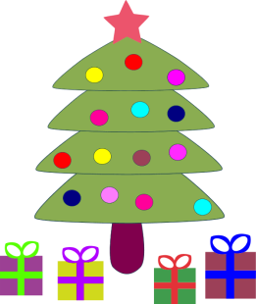

**Wednesday 13th December The Nativity, Christmas show**

**11am all children are asked to attend the show.**

christmas raffle prizes include large Christmas hamper,

Chocolate hamper, hot chocolate hamper, Shortbread

biscuits. Raffle to be drawn at the show.

Ask staff for tickets. £1 a strip.

Thursday 14th Children’s last day a preschool. Normal session times will run.

C:\Program Files (x86)\Microsoft Office\MEDIA\CAGCAT10\j0183290.wmfFriday 15th All children are invited to the F.I.G Christmas Party 9.00 till 11.00 £3 per child to include party games,

Food and a visit with gift from our

Special visitor between 11.00 and 11.30.

We return to preschool on Thursday 4th January 2018

 All the staff At F.I.G would like to wish you

A Merry Christmas and

a prosperous new year